Course: AI Assisted Coding

Week 7
Name:G. Karthikeya
BATCH-14
2303A510D2

Task 1: AI-Assisted Syntax and Code Quality Review
Scenario
You join a development team and are asked to review a junior
developer’s Python script that fails to run correctly due to basic coding
mistakes. Before deployment, the code must be corrected and
standardized.
Task Description
You are given a Python script containing:
• Syntax errors
• Indentation issues
• Incorrect variable names
• Faulty function calls
Use an AI tool (GitHub Copilot / Cursor AI) to:
• Identify all syntactic and structural errors
• Correct them systematically
• Generate an explanation of each fix made
Expected Outcome
• Fully corrected and executable Python code
• AI-generated explanation describing:
o Syntax fixes
o Naming corrections
o Structural improvements
• Clean, readable version of the script

Task 1 – Wrong Code (Syntax & Structural Errors)
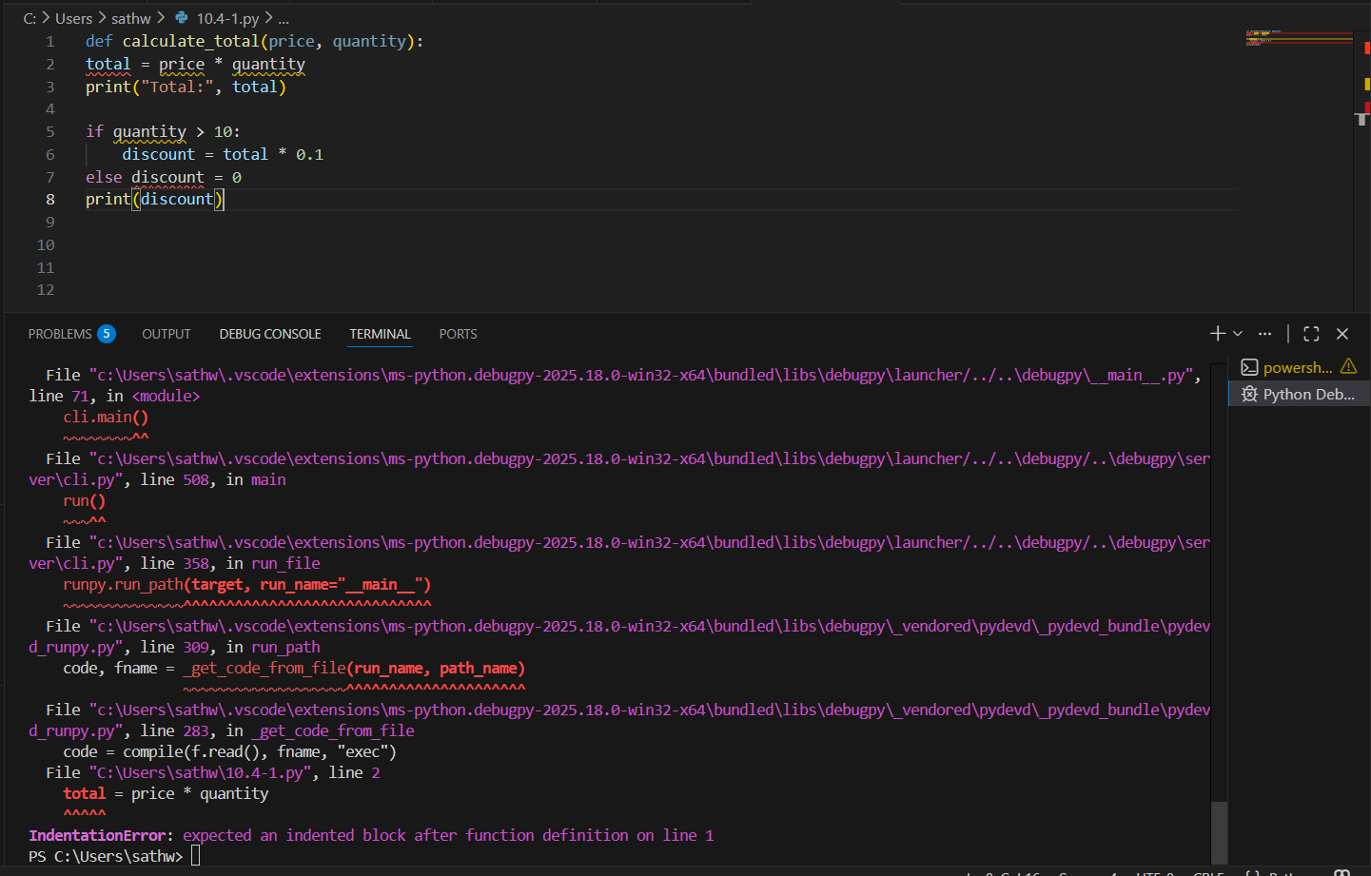

Errors Present
- Missing comma in parameters
- Missing colon
- No indentation
- Python 2 print statement
- Function name mismatch
- Missing comma in function call
- No return statement

Prompt Used
“Review the following Python script. Identify syntax errors, indentation issues, naming problems, and structural mistakes. Correct the code and explain each fix according to PEP 8 standards.”

Corrected Code (With Input)
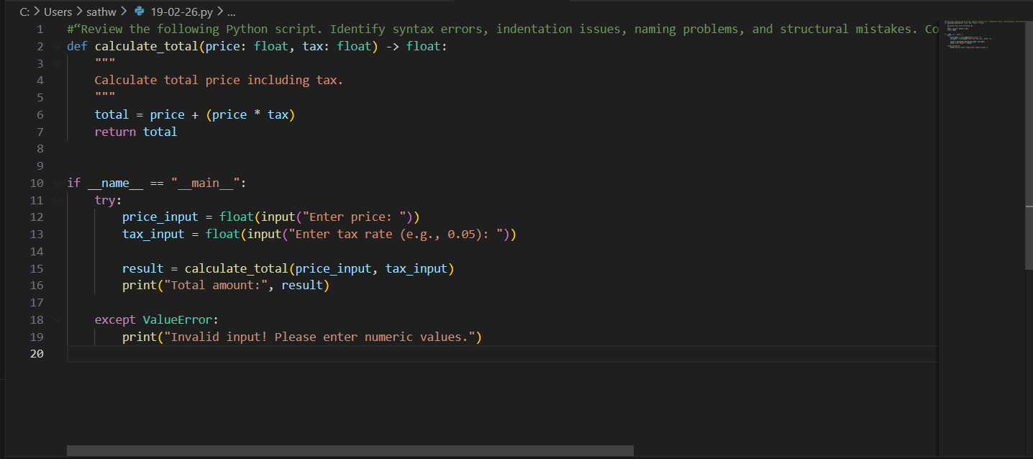

OUTPUT:
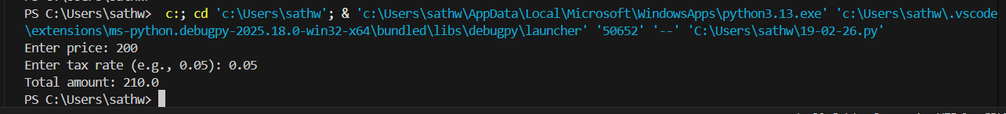

Task 2: Performance-Oriented Code Review
Scenario
A data processing function works correctly but is inefficient and slows
down the system when large datasets are used.
Task Description
You are provided with a function that identifies duplicate values in a list
using inefficient nested loops.
Using AI-assisted code review:
• Analyze the logic for performance bottlenecks
• Refactor the code for better time complexity
• Preserve the correctness of the output
Ask the AI to explain:
• Why the original approach was inefficient
• How the optimized version improves performance
Expected Outcome
• Optimized duplicate-detection logic (e.g., using sets or hash-
based structures)
• Improved time complexity
• AI explanation of performance improvement
• Clean, readable implementation

Original Inefficient Code

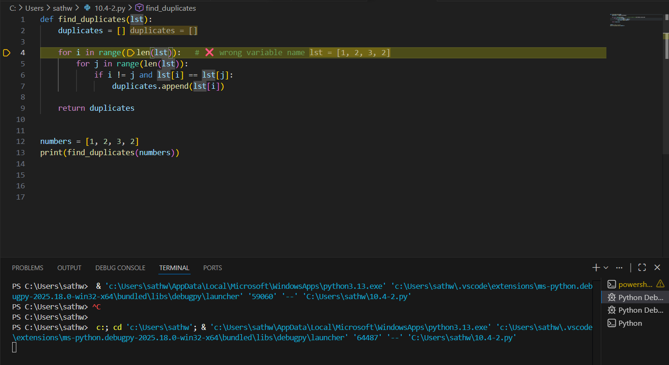
AI Identified Issues
- Nested loops → O(n²)
- Duplicate values repeated
- Inefficient for large lists

Prompt Used
“Analyze the performance of this duplicate detection function. Identify bottlenecks and refactor it to improve time complexity while preserving correctness.”

Optimized Code (With Input)
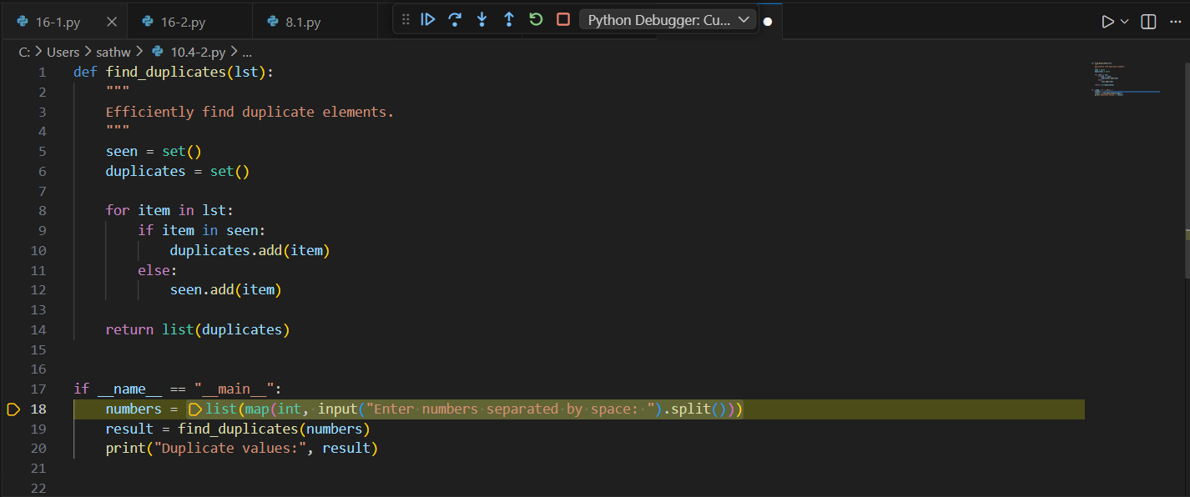

OUTPUT:
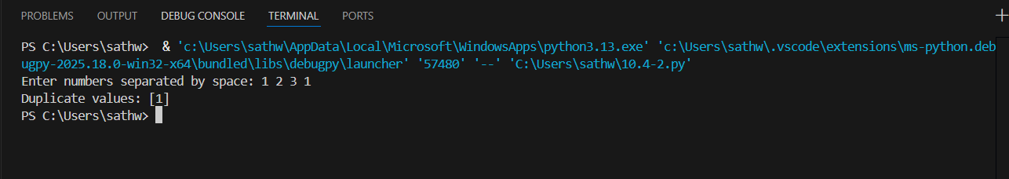

Task 3: Readability and Maintainability Refactoring
Scenario
A working script exists in a project, but it is difficult to understand due to
poor naming, formatting, and structure. The team wants it rewritten for
long-term maintainability.
Task Description
You are given a poorly structured Python function with:
• Cryptic function names
• Poor indentation
• Unclear variable naming
• No documentation
Use AI-assisted review to:
• Refactor the code for clarity
• Apply PEP 8 formatting standards
• Improve naming conventions
• Add meaningful documentation
Expected Outcome
• Clean, well-structured code
• Descriptive function and variable names
• Proper indentation and formatting
• Docstrings explaining the function purpose
• AI explanation of readability improvements

Original Inefficient Code
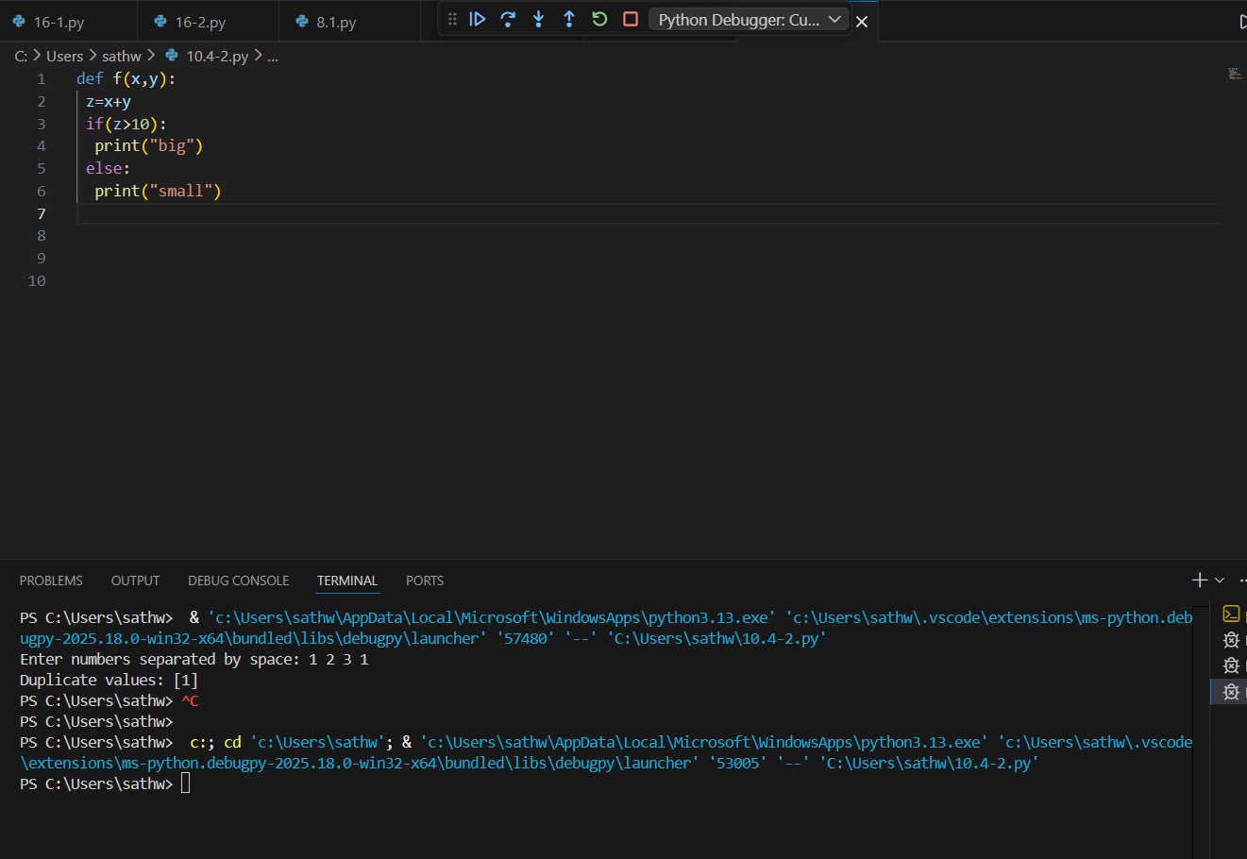

AI Identified Issues
- Unclear function name
- Poor indentation
- No documentation
- Cryptic variables

Prompt Used
“Refactor this Python function to improve readability, apply PEP 8 standards, use meaningful variable names, and add proper documentation.”

Optimized Code (With Input)
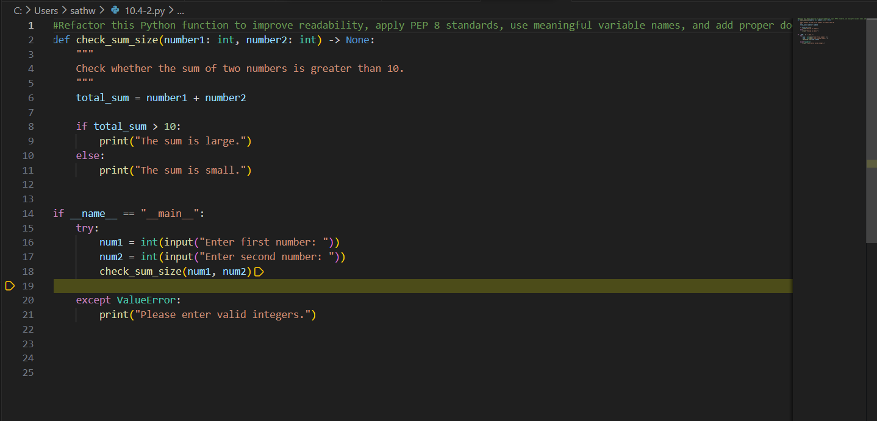
OUTPUT:
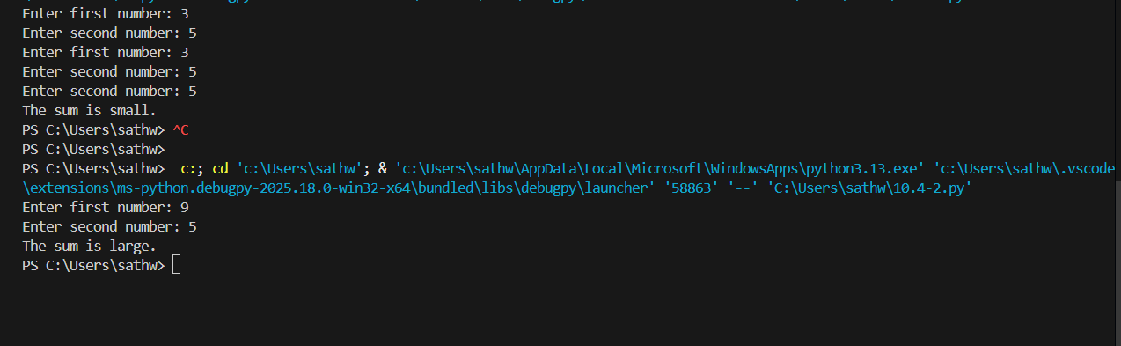

Task 4: Secure Coding and Reliability Review
Scenario
A backend function retrieves user data from a database but has security
vulnerabilities and poor error handling, making it unsafe for production
deployment.
Task Description
You are given a Python script that:
• Uses unsafe SQL query construction
• Has no input validation
• Lacks exception handling
Use AI tools to:
• Identify security vulnerabilities
• Refactor the code using safe coding practices
• Add proper exception handling
• Improve robustness and reliability
Expected Outcome
• Secure SQL queries using parameterized statements
• Input validation logic
• Try-except blocks for runtime safety
• AI-generated explanation of security improvements
• Production-ready code structure

Original Inefficient Code

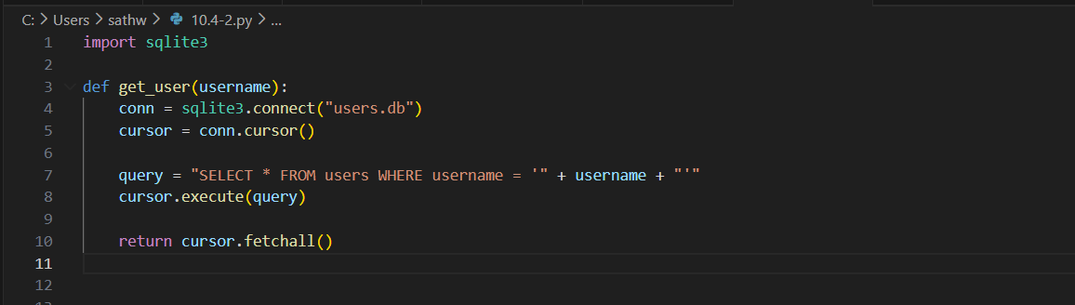

AI Identified Issues
- SQL Injection vulnerability
- No validation
- No exception handling
- Connection not safely closed

Prompt Used
“Identify security vulnerabilities in this database code. Refactor using parameterized queries, input validation, and exception handling.”

CREATE A DATABASE FILE:

CODE WITH INPUT:
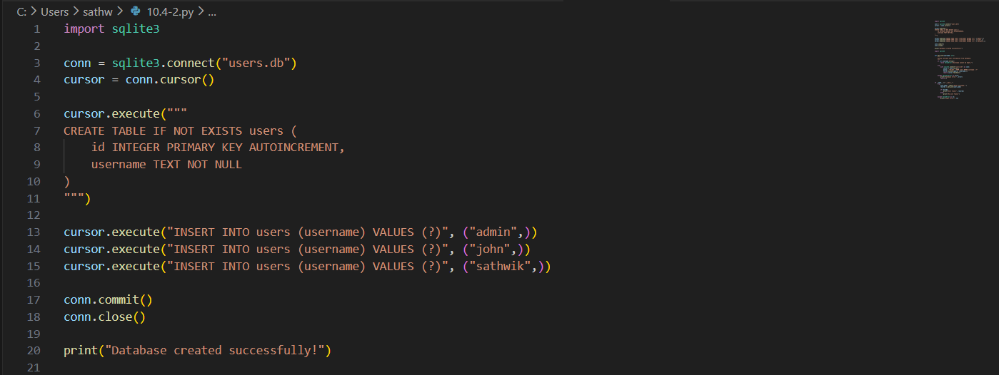

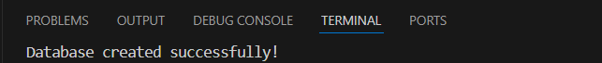

Optimized Code (With Input)
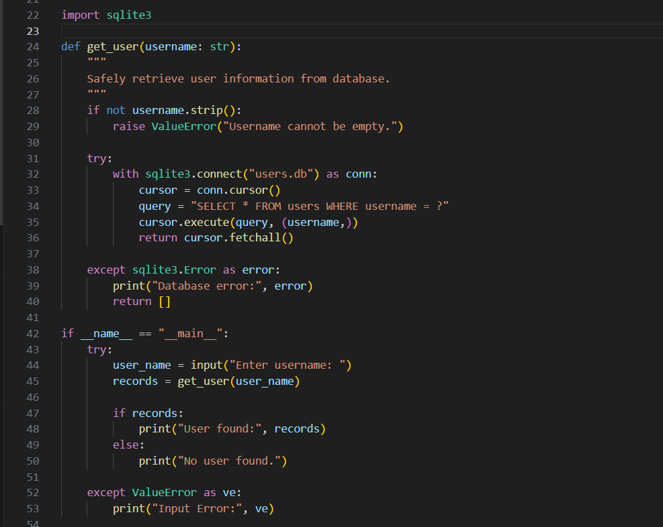

OUTPUT:
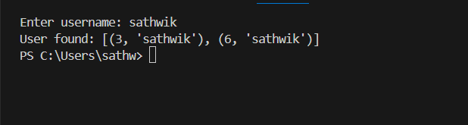

Task 5: AI-Based Automated Code Review Report
Scenario
Your team uses AI tools to perform automated preliminary code reviews
before human review, to improve code quality and consistency across
projects.
Task Description
You are provided with a poorly written Python script.
Using AI-assisted review:
• Generate a structured code review report that evaluates:
o Code readability
o Naming conventions
o Formatting and style consistency
o Error handling
o Documentation quality
o Maintainability
The task is not just to fix the code, but to analyze and report on quality
Issues

Original Inefficient Code
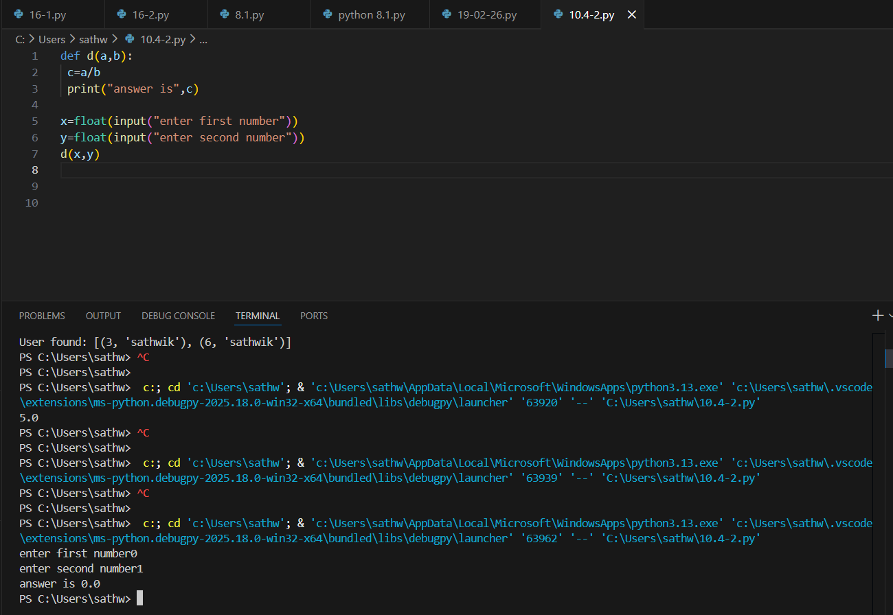
AI Code Review Report
1. Readability Issues
- Function name not descriptive
- No documentation
2. Naming Problems
- Variables unclear
3. Formatting Issues
- Not PEP 8 compliant
4. Error Handling Risks
- Division by zero crash possible
5. Maintainability Concerns
- Not reusable
- No return value

Prompt Used for AI Review
“Generate a structured code review report for the following Python script. Evaluate readability, naming conventions, formatting, style consistency, error handling, documentation quality, maintainability, and identify code smells and risk areas. Do not just fix the code — provide detailed analysis.”

Optimized Code (With Input)
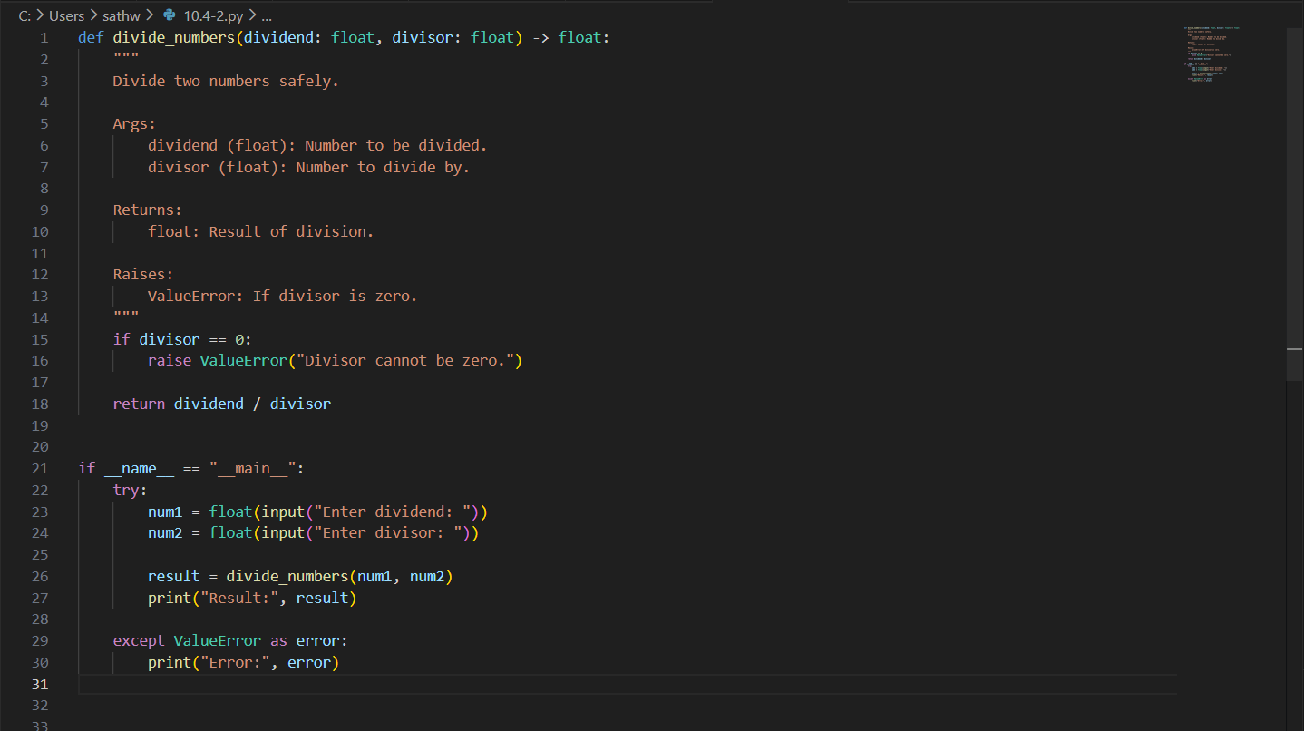

OUTPUT:
